**Chapter Two: Functional Requirement**

**2.1 User requirement specification**

**2.1.1 Dental clinic services system URS**

**Patient**

URS-01: Patient can view the dentist schedule in a website and a mobile application

URS-02: Patient can view the queue in schedule in a website and a mobile application

URS-03: Patient can view his/her appointment in patient schedule in a website and a mobile application

**Officer**

URS-04: Officer can view the dentist schedule

URS-05: Officer can add/edit/delete schedule

URS-06: Officer can manage the patient queue

URS-07: Officer can accept the reservation of the patient

**Dentist**

URS-08: Dentist can view the dentist schedule

URS-09: Dentist can view the patient schedule

URS-10: Dentist can add/edit/delete the schedule

URS-11: Dentist can manage the patients’ queue

URS-12: Dentist can submit the reserving from patients’ request

**Appointment management**

**Patient**

URS-13: Patient can make an appointment by them self

URS-14: Patient can change his/her appointment date

URS-15: Patient can get the reminder of an appointment date

URS-16: New patient can receive the appointment detail in the QR code

**Officer**

URS-17: Officer can view the patients’ appointment in the schedule

URS-18: Officer can change the patient appointment date

URS-19: Officer can make an appointment date for the patient

URS-20: Officer can approve the appointment that patient request

**Dentist**

URS-21: Dentist can view the patients’ appointment in the schedule

URS-22: Dentist can change the patient appointment date

URS-23: Dentist can make an appointment date for the patient

URS-24: Dentist can approve the appointment that patient request

**User registration and authentication**

**Patient**

URS-25: Patient can login to the website and the mobile application by using patient ID

**Officer**

URS-26: Officer can login to the dental clinic website

URS-27: Officer can create the patient account for new patient

URS-28: Officer can create dentist account for dentist

**Dentist**

URS-29: Dentist can login to the dental clinic website

**2.1.2 Dental clinic services system SRS**

SRS-01: System shall provide the dentist schedule interface in mobile application

SRS-02: System shall provide the dentist schedule interface in website

SRS-03: System shall provide the patient schedule interface in mobile application

SRS-04: System shall provide the patient schedule interface in website

SRS-05: System shall add new schedule in to the database

SRS-06: System shall edit the schedule in the database

SRS-07: System shall delete the schedule in the database

SRS-08: System shall add the patients’ reservation to clinic queue of each day

SRS-09: System shall remove the patients’ queue from the clinic queue

SRS-10: System shall show the patients’ queue in the patients’ schedule

SRS-11: System shall delete the patients’ queue from the patient schedule

SRS-12: System shall send the confirm message to the patient after the reservation is accepted

SRS-13: System shall send the cancel message to the patient after the reservation is cancel

SRS-14: System shall save the reservation into the dentist schedule

SRS-15: System shall provide the patient appointment interface in mobile application

SRS-16: System shall provide the patient appointment interface in website

SRS-17: System shall sent reservation request to the officer

SRS-18: System shall send the reminder of an appointment date to the patient 2 days before the appointment date

SRS-19: System shall sent the reminder of an appointment date to the patient 1 day before the appointment date

SRS-20: System shall sent the reminder of an appointment in the appointment date

SRS-21: System shall send the reminder of an appointment date to the patient in SMS

SRS-22: System shall send the reminder of an appointment date to the patient in email

SRS-23: System shall send the reminder of an appointment date to the patient in QR code

SRS-24: System shall generate the patient reservation information to be a QR code

SRS-25: System shall send the appointment detail in the QR code to the patient via the mobile application and in the email

SRS-26: System shall send changing message to the patient “Sorry, We have to change your appointment date”

SRS-27: System shall provide the login interface in website

SRS-28: System shall check patient ID format the database

SRS-29: System shall check patient ID characters not over 7 characters

SRS-30: System shall check patient password from database

SRS-31: System shall show error message “Wrong username or password”

SRS-32: System shall check ID format the database

SRS-33: System shall check ID characters not over 7 characters

SRS-34: System shall check password from database

SRS-35: System shall show error message “Wrong ID or password”

SRS-36: System shall provide the new patient registration interface in website

SRS-37: System shall generate the patient ID

SRS-38: System shall collect patients’ name, surname, address, telephone number, and email into the database

SRS-39: System shall provide the dentist registration interface in website

SRS-40: System shall generate the ID

SRS-41: System shall collect dentist’ name, surname, address, telephone number, email, and status as a dentist into the database

**2.2 User requirement specification with system requirement specification**

**Patient**

URS-01: Patient can view the dentist schedule in a website and a mobile application

SRS-01: System shall provide the dentist schedule interface in mobile application

SRS-02: System shall provide the dentist schedule interface in website

URS-02: Patient can view the queue in schedule in a website and a mobile application

SRS-01: System shall provide the dentist schedule interface in mobile application

SRS-02: System shall provide the dentist schedule interface in website

URS-03: Patient can view his/her appointment in patient schedule in a website and a mobile application

SRS-03: System shall provide the patient schedule interface in mobile application

SRS-04: System shall provide the patient schedule interface in website

**Officer**

URS-04: Officer can view the dentist schedule

SRS-02: System shall provide the dentist schedule interface in website

URS-05: Officer can add/edit/delete schedule

SRS-02: System shall provide the dentist schedule interface in website

SRS-05: System shall add new schedule in to the database

SRS-06: System shall edit the schedule in the database

SRS-07: System shall delete the schedule in the database

URS-06: Officer can manage the patient queue

SRS-08: System shall add the patients’ reservation to clinic queue of each day

SRS-09: System shall remove the patients’ queue from the clinic queue

SRS-10: System shall show the patients’ queue in the patients’ schedule

SRS-11: System shall delete the patients’ queue from the patient schedule

URS-07: Officer can accept the reservation of the patient

SRS-02: System shall provide the dentist schedule interface in website

SRS-12: System shall send the confirm message to the patient after the reservation is accepted

SRS-13: System shall send the cancel message to the patient after the reservation is cancel

SRS-14: System shall save the reservation into the dentist schedule

**Dentist**

URS-08: Dentist can view the dentist schedule

SRS-02: System shall provide the dentist schedule interface in website

URS-09: Dentist can view the patient schedule

SRS-04: System shall provide the patient schedule interface in website

URS-10: Dentist can add/edit/delete the schedule

SRS-02: System shall provide the dentist schedule interface in website

SRS-05: System shall add new schedule in to the database

SRS-06: System shall edit the schedule in the database

SRS-07: System shall delete the schedule in the database

URS-11: Dentist can manage the patients’ queue

SRS-08: System shall add the patients’ reservation to clinic queue of each day

SRS-09: System shall remove the patients’ queue from the clinic queue

SRS-10: System shall show the patients’ queue in the patients’ schedule

SRS-11: System shall delete the patients’ queue from the patient schedule

URS-12: Dentist can submit the reserving from patients’ request

SRS-02: System shall provide the dentist schedule interface in website

SRS-12: System shall send the confirm message to the patient after the reservation is accepted

SRS-13: System shall send the cancel message to the patient after the reservation is cancel

SRS-14: System shall save the reservation into the dentist schedule

**Appointment management**

**Patient**

URS-13: Patient can make an appointment by them self

SRS-01: System shall provide the dentist schedule interface in mobile application

SRS-02: System shall provide the dentist schedule interface in website

SRS-03: System will provide the patient schedule interface in mobile application

SRS-04: System will provide the patient schedule interface in website

SRS-15: System shall provide the patient appointment interface in mobile application

SRS-16: System shall provide the patient appointment interface in website

SRS-17: System shall sent reservation request to the officer

SRS-18: System will provide interface for making an appointment

URS-14: Patient can change his/her appointment date

SRS-01: System shall provide the dentist schedule interface in mobile application

SRS-02: System shall provide the dentist schedule interface in website

SRS-03: System shall provide the patient schedule interface in mobile application

SRS-04: System shall provide the patient schedule interface in website

SRS-15: System shall provide the patient appointment interface in mobile application

SRS-16: System shall provide the patient appointment interface in website

SRS-17: System shall sent reservation request to the officer

SRS-18: System shall provide interface for making an appointment

SRS-17: System shall delete the old reservation from the database

URS-15: Patient can get the reminder of an appointment date

SRS-18: System shall send the reminder of an appointment date to the patient 2 days before the appointment date

SRS-19: System shall sent the reminder of an appointment date to the patient 1 day before the appointment date

SRS-20: System shall sent the reminder of an appointment in the appointment date

SRS-21: System shall send the reminder of an appointment date to the patient in SMS

SRS-22: System shall send the reminder of an appointment date to the patient in email

SRS-23: System shall send the reminder of an appointment date to the patient in QR code

URS-16: New patient can receive the appointment detail in the QR code

SRS-24: System shall generate the patient reservation information to be a QR code

SRS-25: System shall send the appointment detail in the QR code to the patient via the mobile application and in the email

**Officer**

URS-17: Officer can view the patients’ appointment in the schedule

SRS-04: System shall provide the patient schedule interface in website

URS-18: Officer can change the patient appointment date

SRS-02: System shall provide the dentist schedule interface in website

SRS-04: System shall provide the patient schedule interface in website

SRS-16: System shall provide the patient appointment interface in website

SRS-17: System shall sent reservation request to the officer

SRS-18: System shall provide interface for making an appointment

SRS-17: System shall delete the old reservation from the database

SRS-26: System shall send changing message to the patient “Sorry, We have to change your appointment date”

SRS-23: System shall provide the new appointment date in the patient schedule

URS-19: Officer can make an appointment date for the patient

SRS-02: System shall provide the dentist schedule interface in website

SRS-04: System shall provide the patient schedule interface in website

SRS-15: System shall provide the patient appointment interface in mobile application

SRS-16: System shall provide the patient appointment interface in website

SRS-17: System shall sent reservation request to the officer

URS-20: Officer can approve the appointment that patient request

SRS-25: System shall collect the appointment from the patient request to the database

**Dentist**

URS-21: Dentist can view the patients’ appointment in the schedule

SRS-02: System shall provide the patient schedule interface

URS-22: Dentist can change the patient appointment date

SRS-02: System shall provide the patient schedule interface

SRS-19: System shall provide the patient appointment date making interface

SRS-20: System shall collect the patients’ appointment date information in the database

SRS-21: System shall delete the last patients’ appointment date from the patient schedule and in the database

SRS-22: System shall send changing message to the patient “Sorry, We have to change your appointment date”

SRS-23: System shall provide the new appointment date in the patient schedule

URS-23: Dentist can make an appointment date for the patient

SRS-02: System shall provide the patient schedule interface

SRS-19: System shall provide the patient appointment date making interface

SRS-20: System shall collect the patients’ appointment date information in the database

SRS-23: System shall provide the new appointment date in the patient schedule

SRS-24: System shall send the message to the patient “You have an appointment”

URS-24: Dentist can approve the appointment that patient request

SRS-25: System shall collect the appointment from the patient request to the database

**User registration and authentication**

**Patient**

URS-25: Patient can login to the website and the mobile application by using patient ID

SRS-26: System shall provide the login interface in mobile application

SRS-27: System shall provide the login interface in website

SRS-28: System shall check patient ID format the database

SRS-29: System shall check patient ID characters not over 7 characters

SRS-30: System shall check patient password from database

SRS-31: System shall show error message “Wrong username or password”

**Officer**

URS-26: Officer can login to the dental clinic website

SRS-27: System shall provide the login interface in website

SRS-32: System shall check ID format the database

SRS-33: System shall check ID characters not over 7 characters

SRS-34: System shall check password from database

SRS-35: System shall show error message “Wrong ID or password”

URS-27: Officer can create the patient account for new patient

SRS-36: System shall provide the new patient registration interface in website

SRS-37: System shall generate the patient ID

SRS-38: System shall collect patients’ name, surname, address, telephone number, and email into the database

URS-28: Officer can create dentist account for dentist

SRS-39: System shall provide the dentist registration interface in website

SRS-40: System shall generate the ID

SRS-41: System shall collect dentist’ name, surname, address, telephone number, email, and status as a dentist into the database

**Dentist**

URS-29: Dentist can login to the dental clinic website

SRS-27: System shall provide the login interface in website

SRS-32: System shall check ID format the database

SRS-33: System shall check ID characters not over 7 characters

SRS-34: System shall check password from database

SRS-35: System will show error message “Wrong ID or password”

**Chapter Three: Specific requirement**

**3.1 Use case scenario**

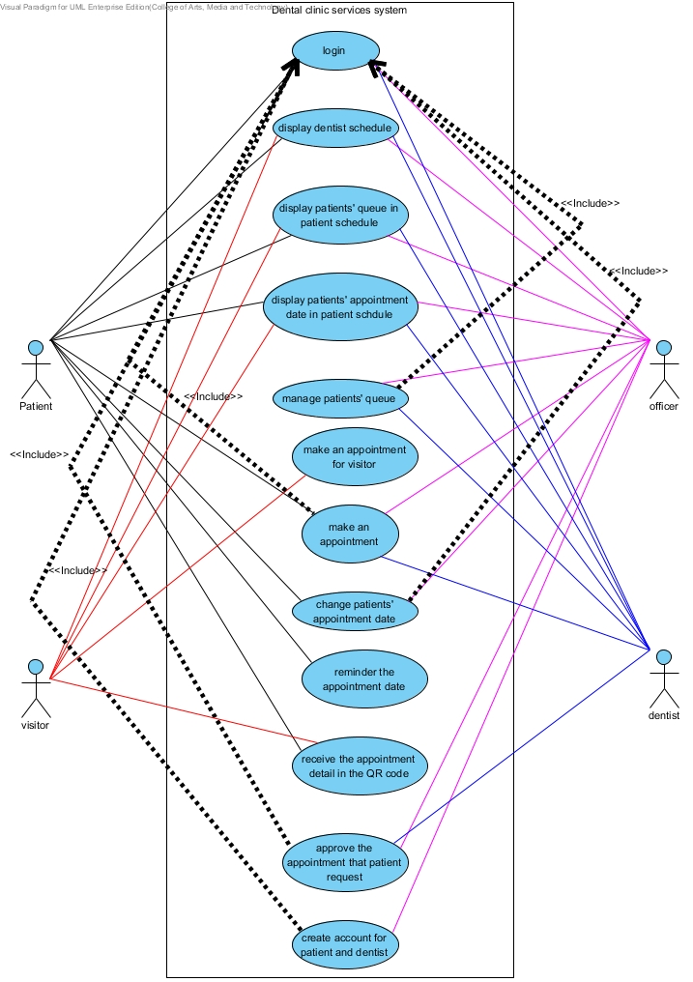

Figure 1: Dental clinic services system use case diagram

**Patient**

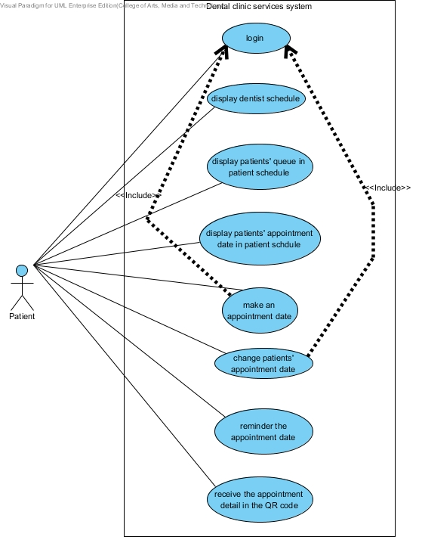

**Visitor**

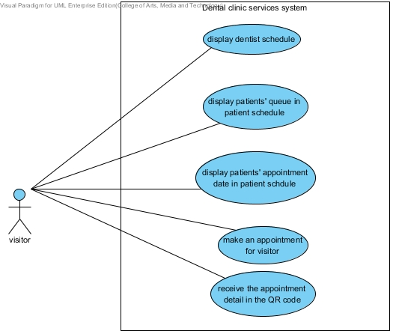

**Officer**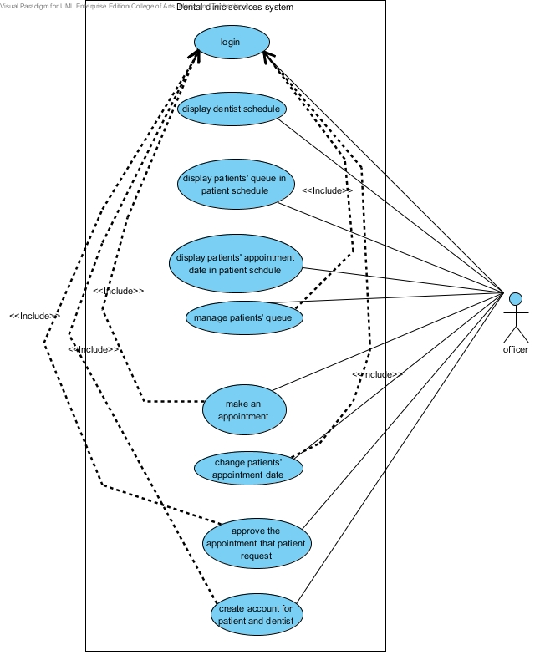

**Dentist**

